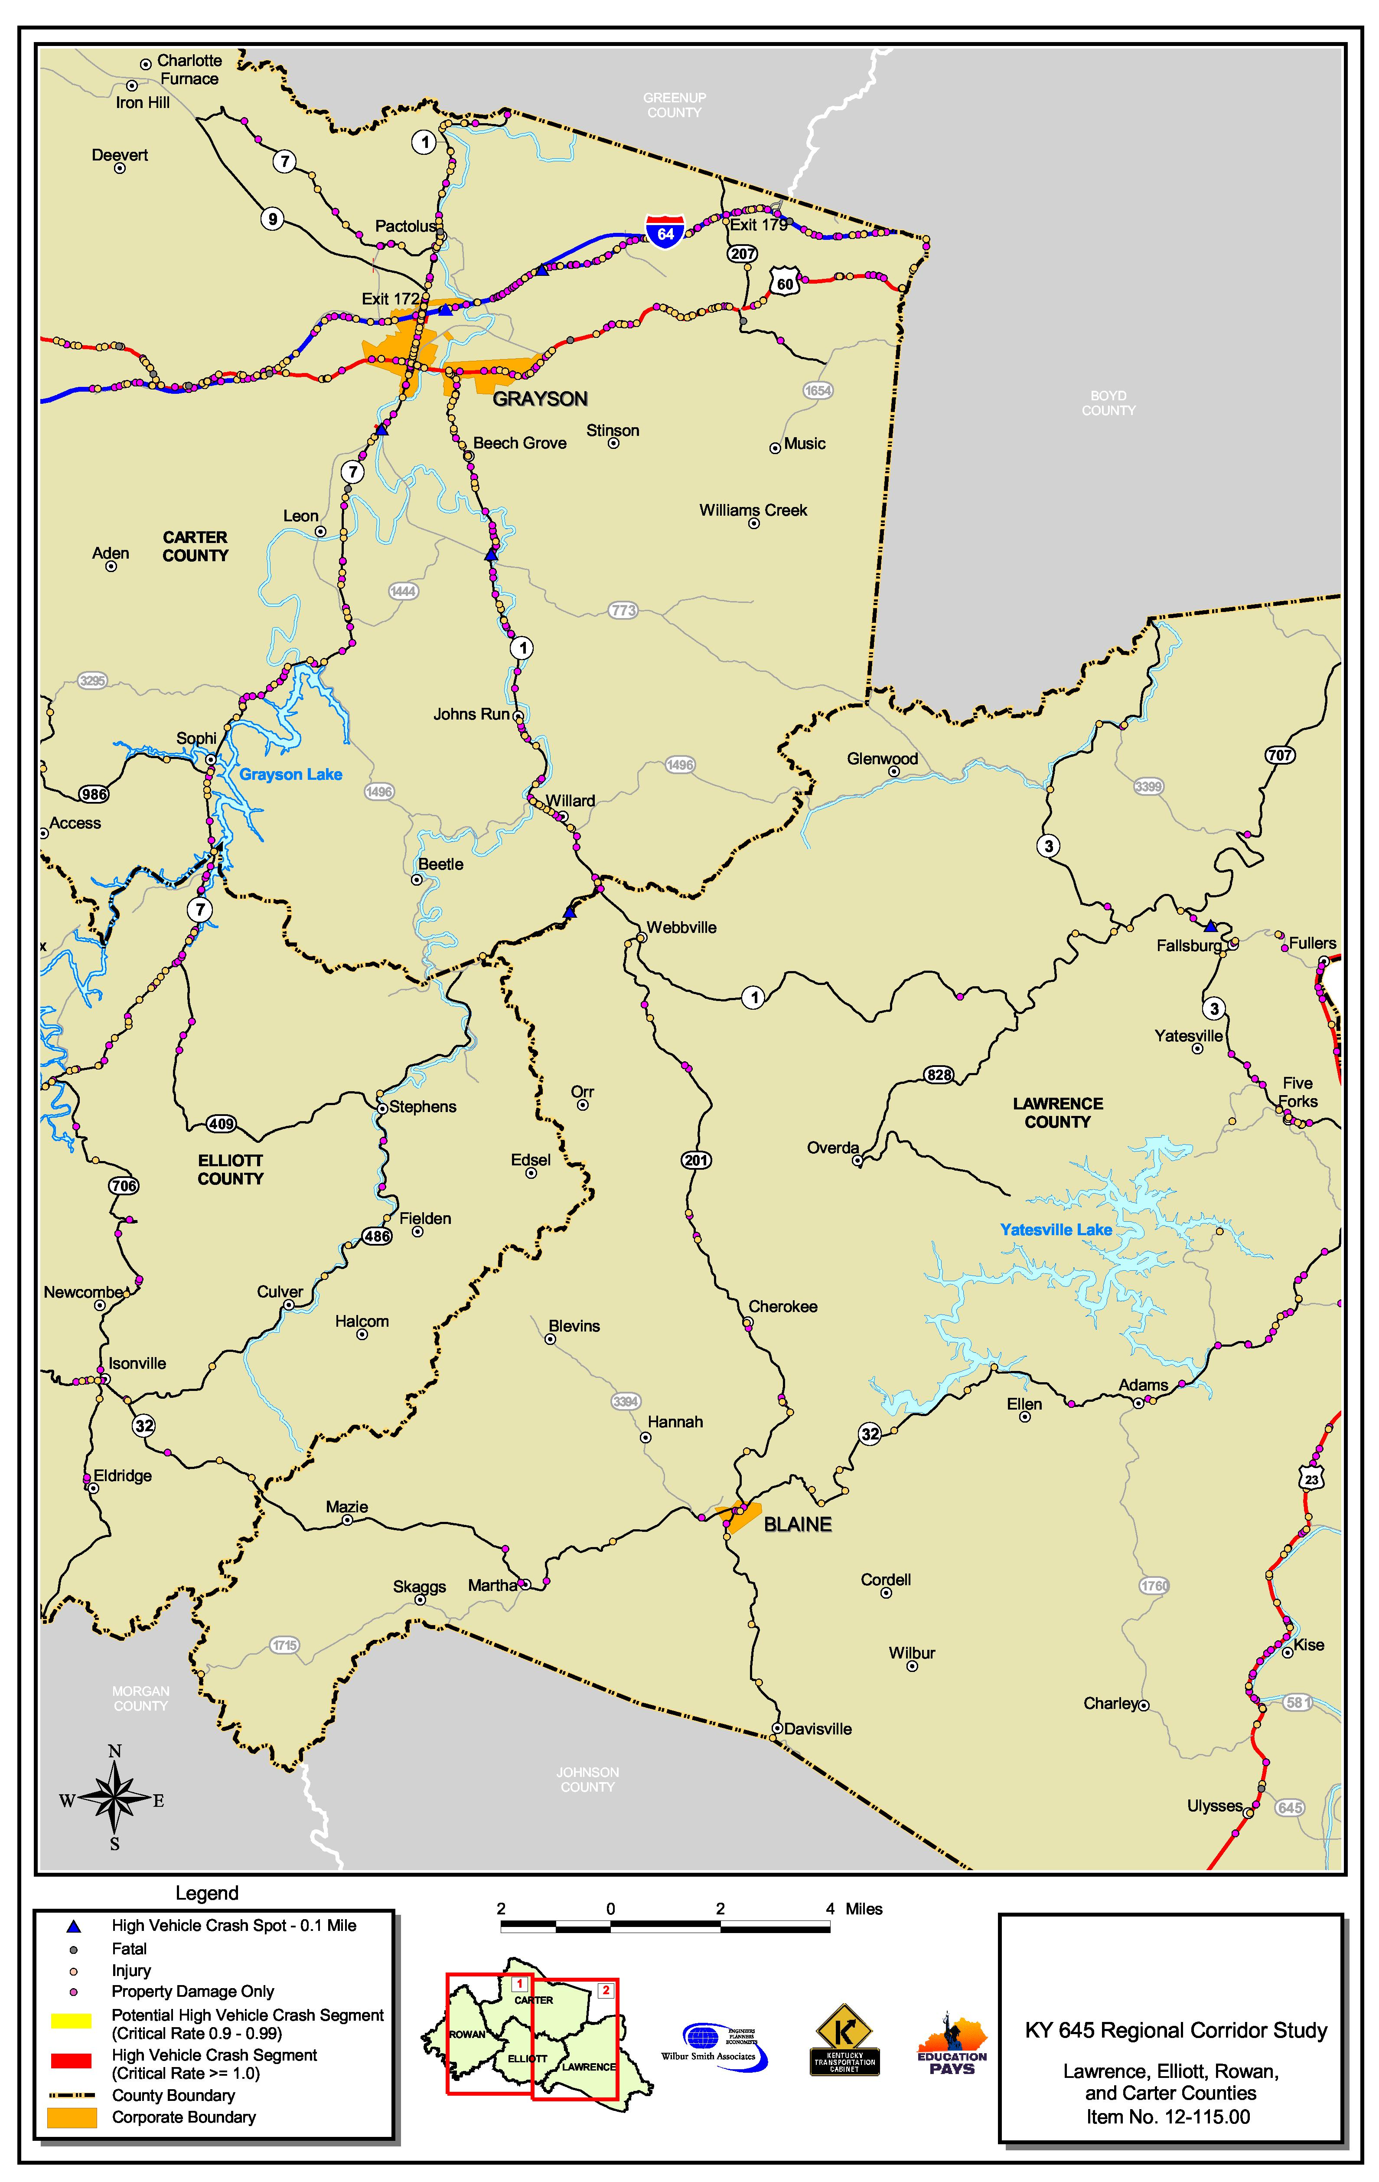

Vehicle Crash Information (cont.)
Source: Kentucky State Police Database (January 1998 to December 2001).

